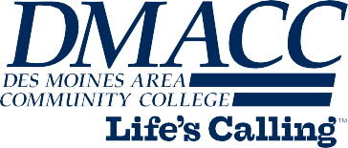

Recipient Name

Street Address

City, State ZIP code

Date

Dear Recipient Name,

This is only placeholder text. Please replace

Sincerely,

Your Name

**DMACC.edu 800-362-2127**

Ankeny Campus

2006 S. Ankeny Blvd. Ankeny, IA 50023-3993

515-964-6200

Boone Campus

1125 Hancock Drive

Boone, IA 50036-5399

515-432-7203

Carroll Campus

906 N. Grant Road Carroll, IA 51401-2525

712-792-1755

Newton Campus

Urban/Des Moines Campus West Des Moines Campus

600 N. 2nd Avenue W. 1100 7th Street

5959 Grand Avenue

Newton, IA 50208-3049 Des Moines, IA 50314-2597 W. Des Moines, IA 50266-5302

641-791-3622

515-244-4226

515-633-2407

DMACC at Perry Vankirk Career Academy | DMACC Career Academy, Hunziker Center, Ames | DMACC Transportation Institute

Evelyn K. Davis Center for Working Families | DMACC Center for Career & Professional Development at Southridge | DMACC Capitol Center